ONE Community Conference
Portals to the Past and Present: Instructional pedagogy with primary sources workshop
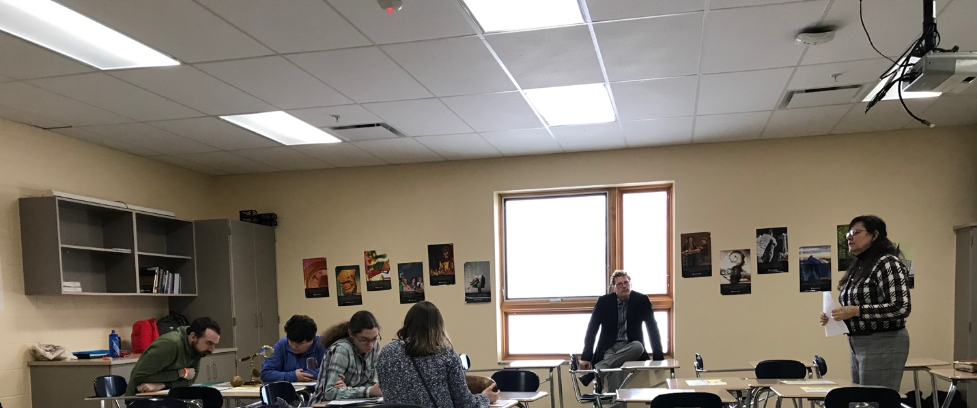

Latin American indigenous cultures and knowledge are often absent or poorly represented in K-12 education curriculum. However, teaching with these sources provide opportunities for students to learn about and engage with different knowledge production and transmission developed in diverse cultural contexts, languages and through non-textual communication systems.

This spring, Dr. Michelle Wibbelsman (Associate Professor of Latin American Indigenous Cultures) Dr. Eric Johnson (Curator, Thompson Library Special Collections) Library, Pamela Espinosa de los Monteros (Latin American Studies Librarian), and Stephanie Porrata (Mary P. Key Resident Librarian in Area Studies), developed the Portals to the Past and Present: Instructional pedagogy with primary sources” workshop to support Olentangy School teachers seeking to diversity their K-12 curriculum presented at the ONE Community Conference Equity and Inclusion Conference. The workshop lead K-12 educators through a replicable active learning activity and discussion using primary sources from the Ohio State University Rare Books & Manuscript Library and the Center for Latin American Studies’ Andean and Amazonian Cultural Artifact Collection. Participants were asked to reflect on the works’ authors, producers, and users by examining an item’s physical characteristics, as well as the materials used to create, preserve, and facilitate their use. The workshop focused on introducing non-western methods of observation and inquiry in order to engage with primary sources in new ways and explore the richness of alternative literacies. Each attendee left with curricular tools that could be integrated into their future lesson plans

The workshop modeled respectful and ethical approaches to working with indigenous knowledge works through the practice of cultural humility. The ONE Community Conference gathered over 450 central Ohio students, teachers, parents, and local students to address equity and inclusion in Olentangy schools and communities. Seven participants participated in the “Portals to the Past and Present” workshop including elementary, middle and high school teachers.

- “This workshop provides me with an idea about alternative texts I can use to engage my middle schoolers who are not impressed with traditional text”.
--ONE Community Workshop participant

Access the workshop presentation slides, handouts, and in-depth resources about concepts covered in the workshop: https://guides.osu.edu/onecommunity2020#s-lg-page-section-7230298

